**1.Creating VPC**

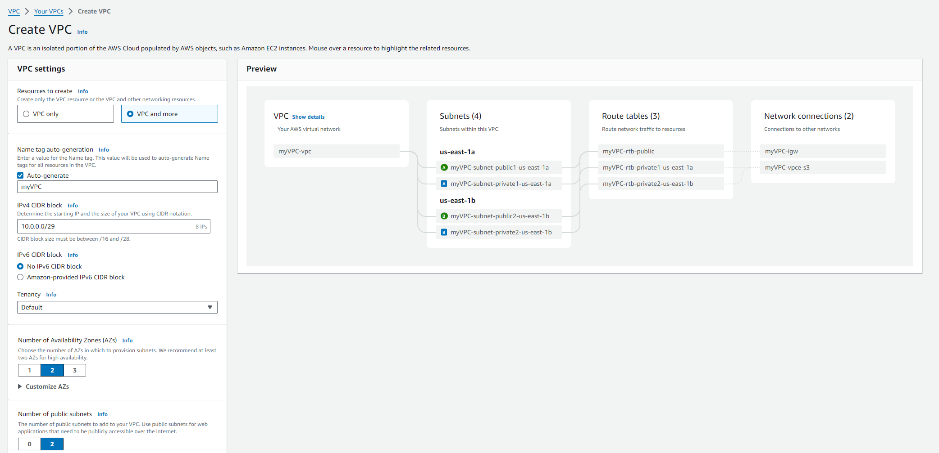

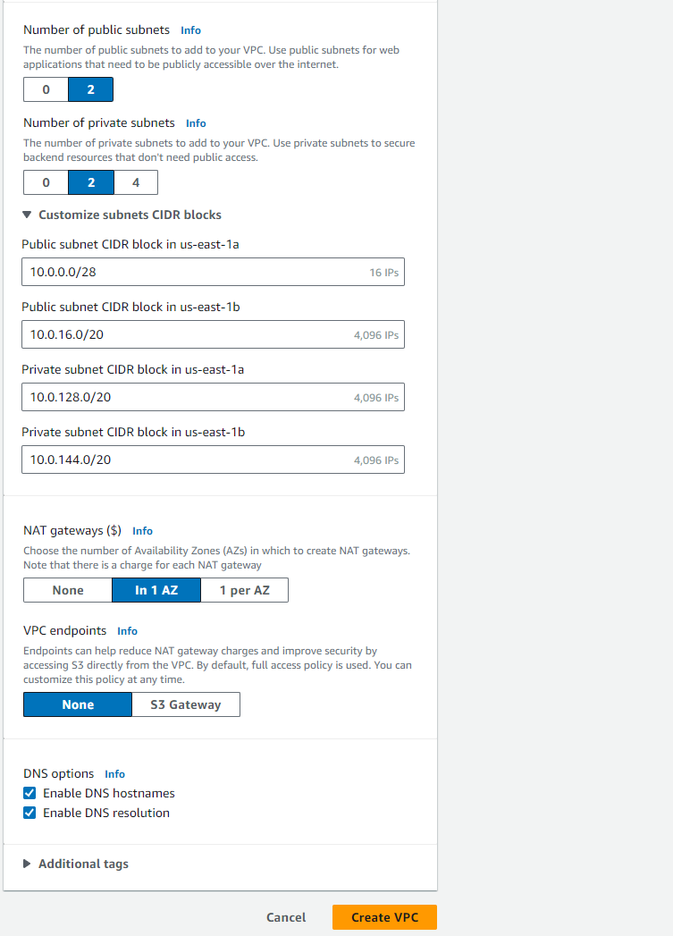

**2.VPC Created**

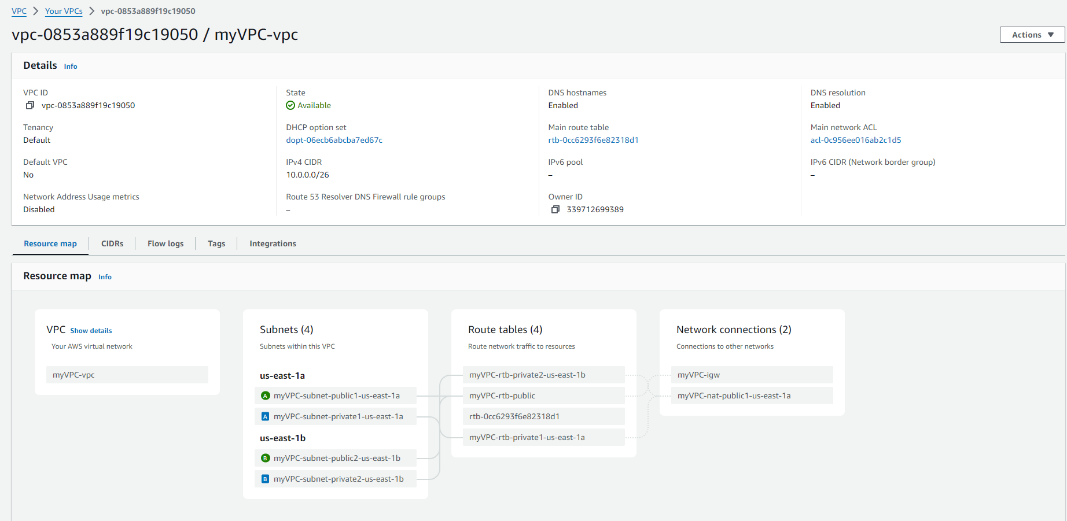

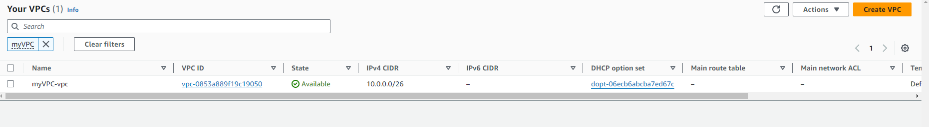

**3.Subnets ( 2 Public & 2 Private Subnets )**

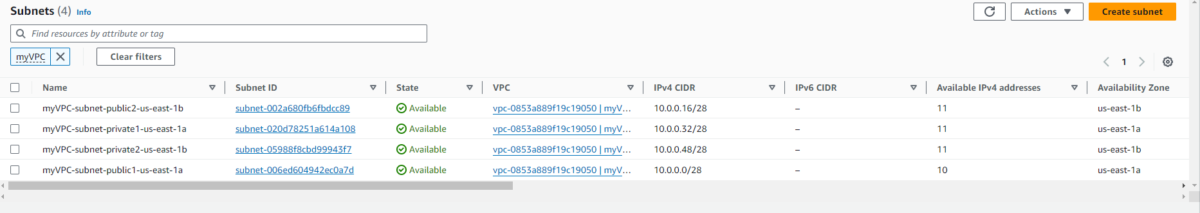

**4.Route Tables**

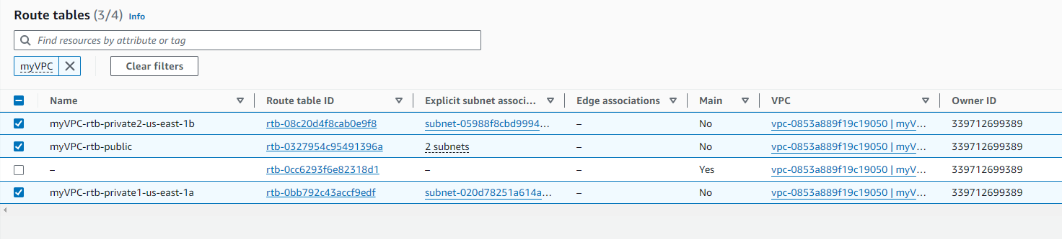

**5.Internet Gateways**

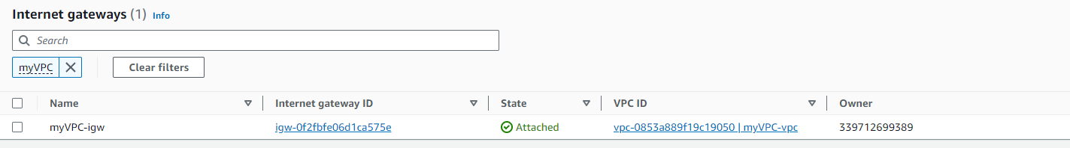

**6.NAT Gateways**

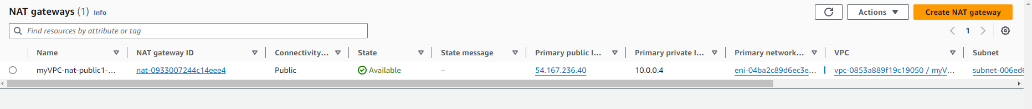

**7.Public Subnets associated with Internet Gateways**

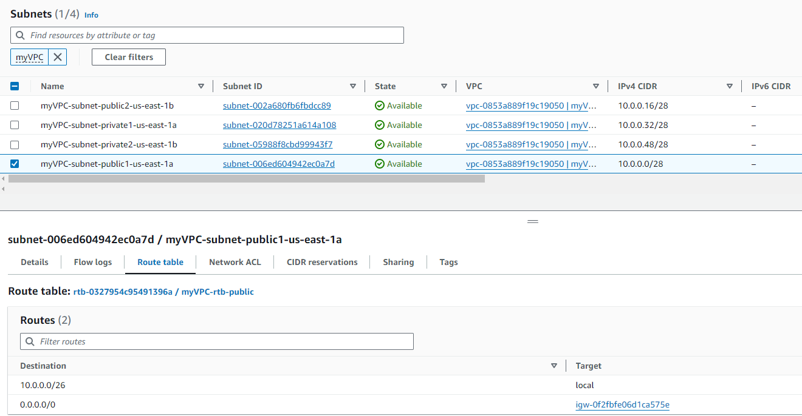

**8. Private Subnets associated with NAT Gateways**

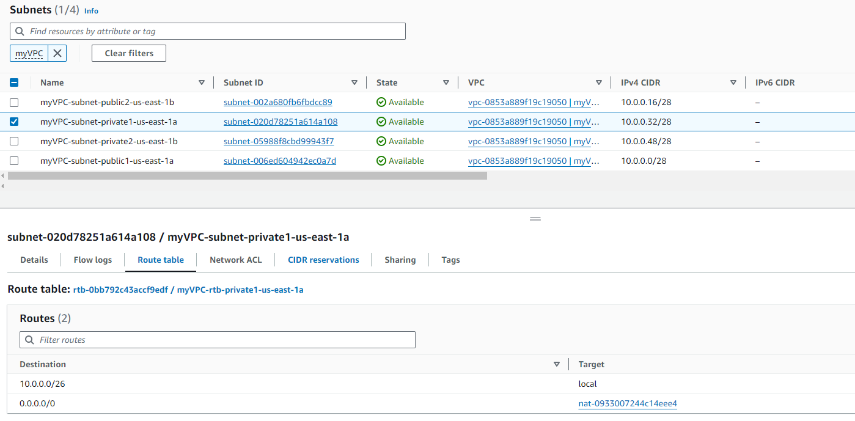

**9. Route tables associated with Subnets**

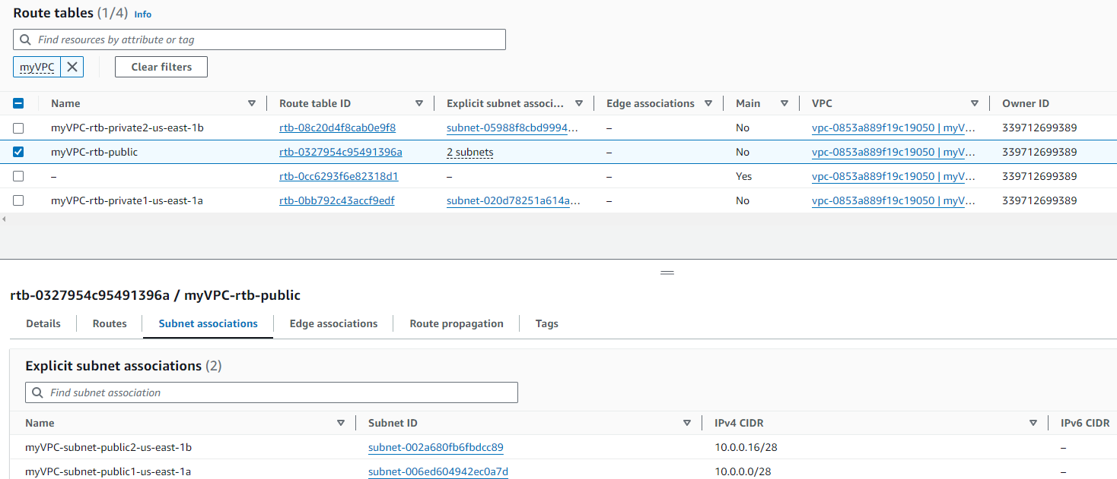

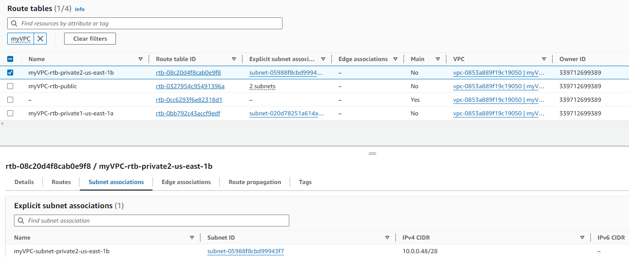

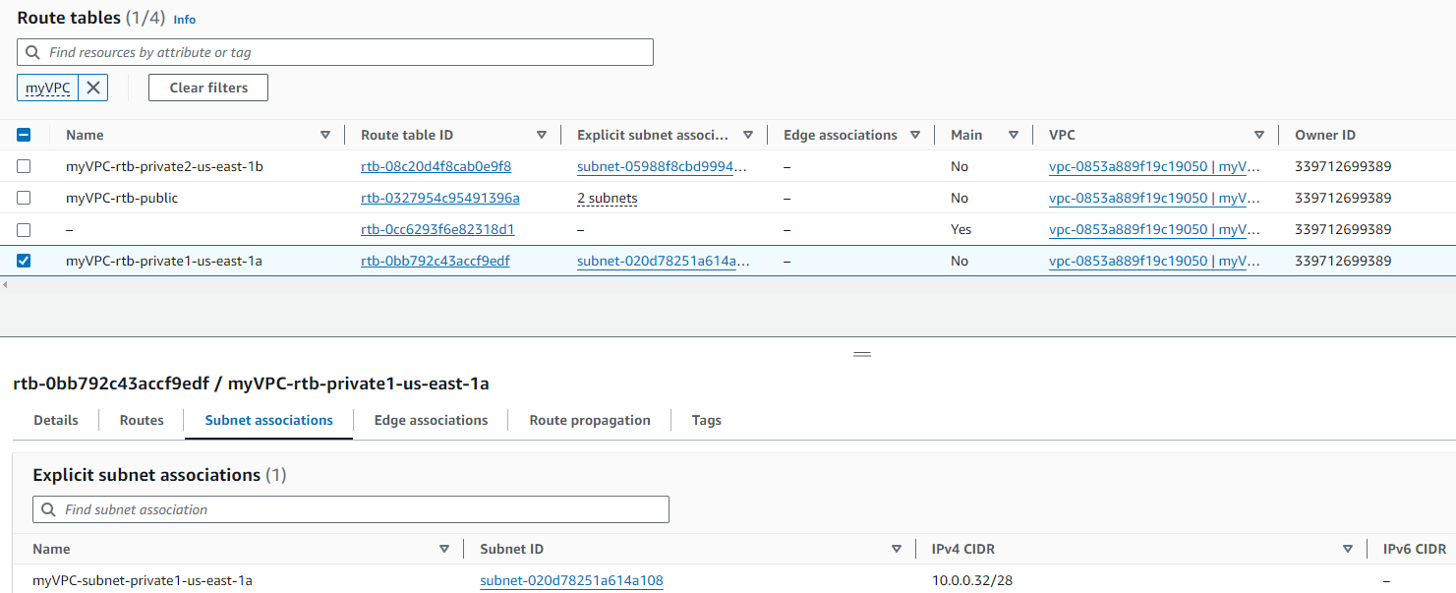

**10.Launching EC2 machine using created VPC**

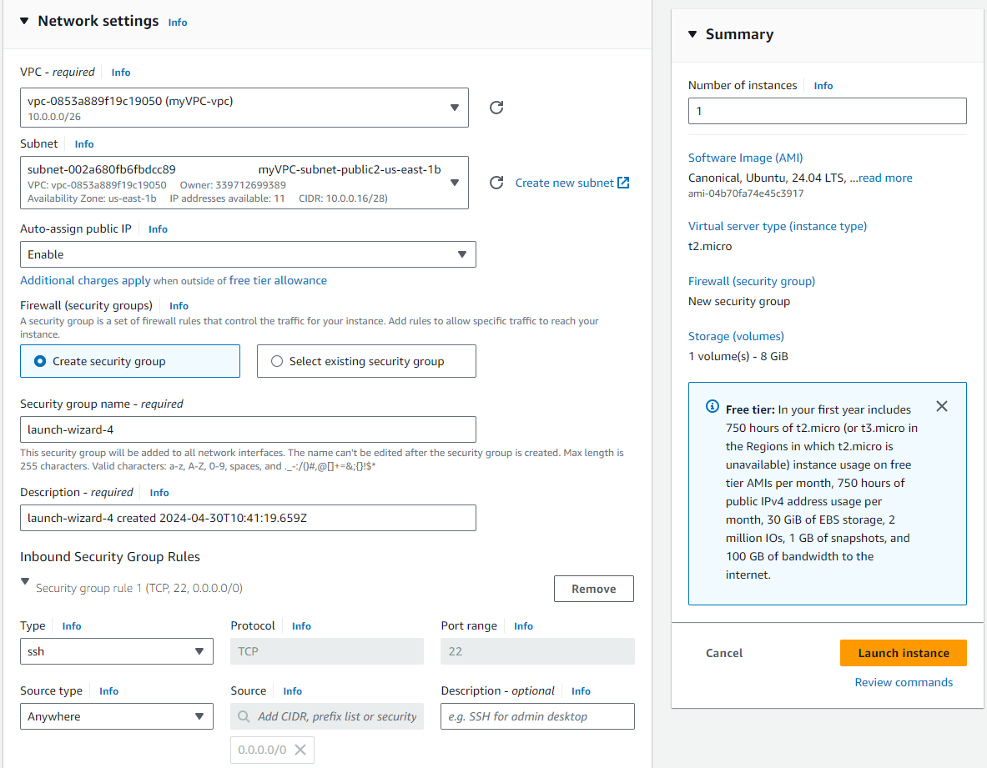

**11.EC2 Instance Running with created VPC**

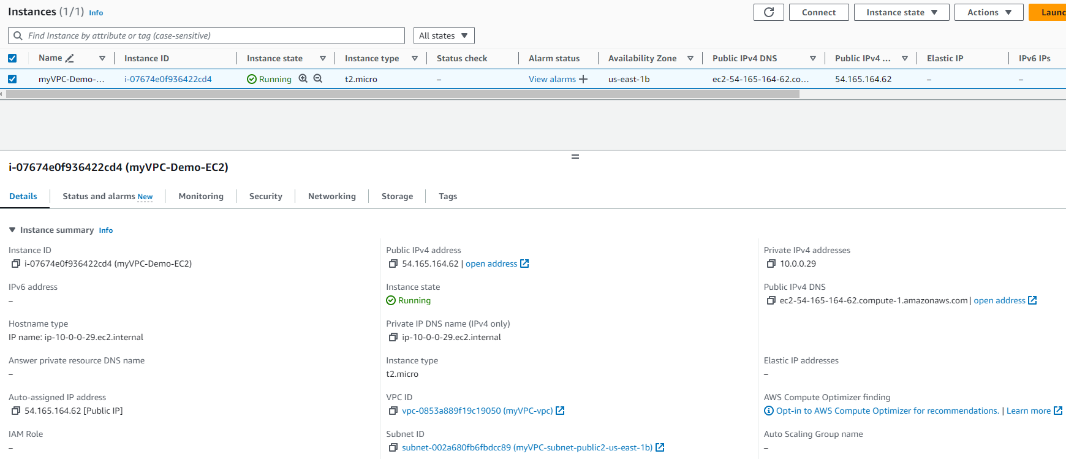

**12. Launched EC2 instance with created VPC Public Subnet**

